

Department of Electronics and Computers
Study programme: Applied Electronics

VERIFICATION PROJECT
Color Sensor

Table of Contents
1 Digital design of the circuit 2
1.1 Block diagram 3
1.2 Description of the general DUT functionality 3
1.3 DUT interfaces 4
1.4 List of DUT functionalities 4
1.5 Schematic diagram 7
1.6 Waveforms 7
1.7 Register table 8
2 Verification of the circuit digital design 12
2.1 Verification environment architecture 12
2.1.1 Driver for the APB interface 13
2.1.2 Driver for the I2C interface 14
2.1.3 Scoreboard / reference model 15
2.1.4 Monitor for the APB interface 15
2.1.5 Monitor for the I2C interface 16
2.1.6 Transaction for the APB interface 17
2.1.7 Transaction for the I2C interface 17
2.1.8 Agent for the APB interface 17
2.1.9 Agent for the I2C interface 18
2.1.10 Coverage collector for the I2C interface 18
2.1.11 Coverage collector for the scoreboard / reference model 18
2.2 List of elements to be verified 19
2.3 Functional coverage elements 20
2.4 Verification scenarios and tests 21
2.5 Results obtained 21

Digital design of the circuit

Block diagram
Description of the general DUT functionality
DUT interfaces
List of DUT functionalities
Schematic diagram
Waveforms
Register table

Block diagram

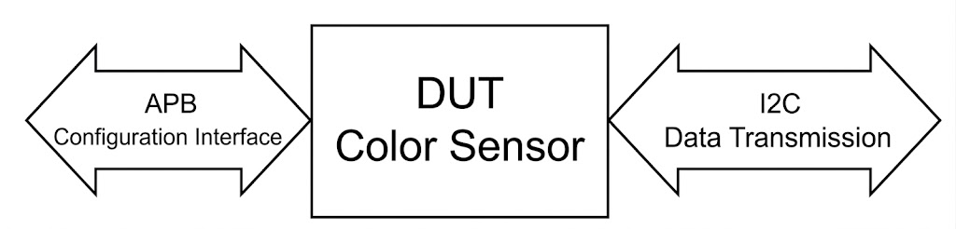
Figure 1. The interfaces of a DUT acting as a color sensor

Description of the general DUT functionality

- Generates 16-bit color values (Red, Green, Blue, Clear, Infrared).
- Through the APB protocol, the sensor parameters can be configured, and the raw values can also be read through registers specific to each color channel.
- It has a status register that indicates communication errors on the I2C interface.
- The sensor has only a single operating mode: continuous.
- It allows data transmission on the I2C interface in Little Endian or Big Endian.
- The I2C clock frequency (SCL) can be configured.

DUT interfaces
Table 1. The signals of the APB interface
APB Interface
Signal name | Number of bits | Direction | Description
paddr | 5 | Input | APB addr bus
psel | 1 | Input | select
penable | 1 | Input | enable
pwrite | 1 | Input | APB write access - HIGH / read - LOW
pwdata | 32 | Input | APB write data
prdata | 32 | Output | Read data
pready | 1 | Output | ack
pslverr | 1 | Output | slave error (HIGH - error, LOW - success)

Table 2. The signals of the I2C interface
I2C Interface
Signal name | Number of bits | Direction | Description
SCL | 1 | Output | Serial clock
SDA | 1 | I/O | Serial data

List of DUT functionalities
- The module simulates a color sensor that generates 16-bit values for the following channels:
  - Red
  - Green
  - Blue
  - Clear
  - Infrared
- The raw values of each channel are stored in dedicated registers and are accessible through the APB interface.
- The module allows configuring the sensor parameters through the APB interface:
  - Selection of the data transmission order: Little Endian or Big Endian;
  - The I2C address that the sensor must access in order to transmit the data;
  - The I2C clock frequency (SCL):
    - 00 -> 100 kHz (Standard mode); in simulation it is 10 MHz
    - 01 -> 400 kHz (Fast mode); in simulation it is 41.66 MHz
    - 10 -> 1 MHz (Fast mode plus); in simulation it is 125 MHz
    - 11 -> 3.4 MHz (High-speed mode); in simulation it is 250 MHz
- The LFSR polynomials for each color channel:
  - Clear channel -> $x^{14}+x^{5}+x^{3}+x+1$
  - Red channel -> $x^{11}+x^{9}+1$
  - Green channel -> $x^{13}+x^{4}+x^{3}+x+1$
  - Blue channel -> $x^{12}+x^{6}+x^{4}+x+1$
  - Infrared channel -> $x^{8}+x^{6}+x^{5}+x^{4}+1$
- The module includes a status register that:
  - Indicates communication errors over the I2C interface (Detected error: NACK);
  - Provides information about the sensor state (sensor active/inactive, busy/free);
- The sensor supports only a single operating mode, continuous. Whenever the color values are updated, they will be transmitted on the I2C interface.
- Data can be transmitted on the I2C interface in the format:
  - Little Endian: the least significant byte is transmitted first;
  - Big Endian: the most significant byte is transmitted first;
- The endianness mode is configured through the configuration register.
- Through an APB command, the sensor can be turned on/off (default is off), and the color channels can be individually disabled. When a channel is off, only values of 1 will be transmitted on the I2C interface for that channel (the communication lines are held at VDD / pull-up).
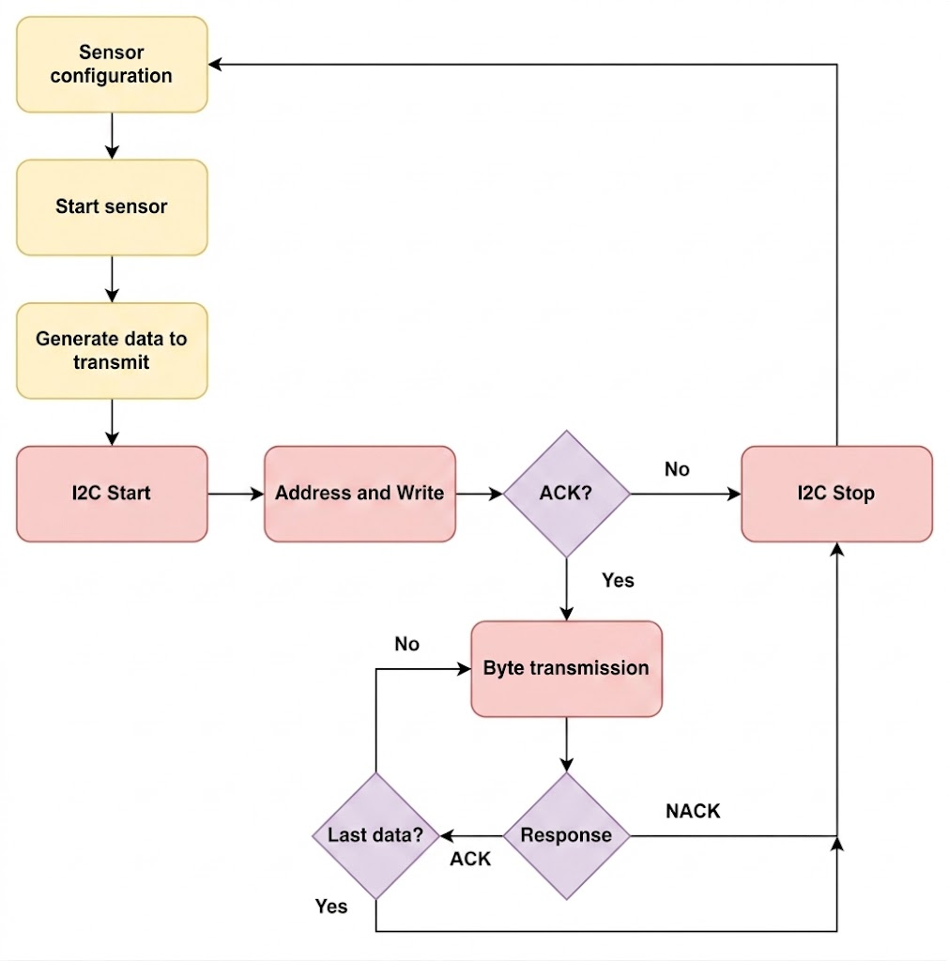
Figure 2. DUT functionality
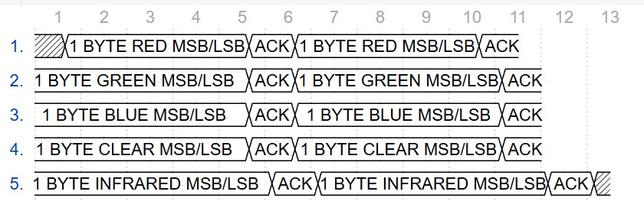

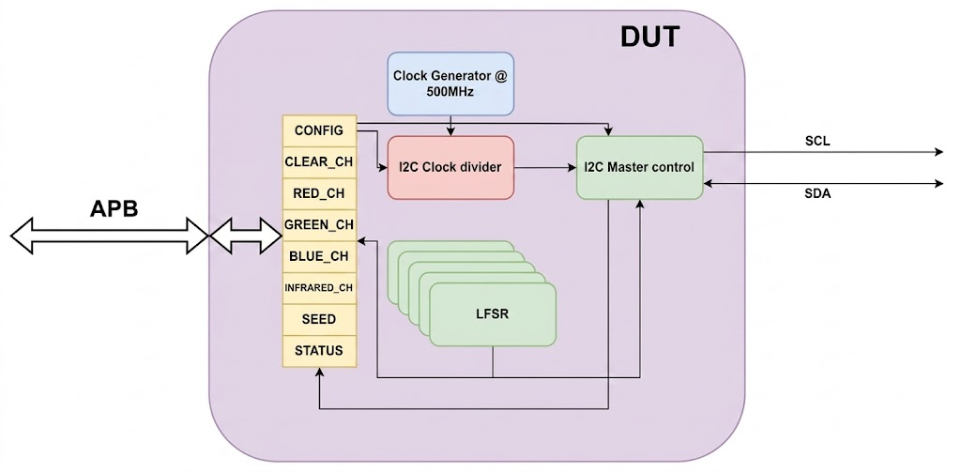
Figure 3. The order of data transmission on I2C
Figure 4. The schematic diagram of the DUT

Schematic diagram
Parameters:
- ADDR_WIDTH: The size of the APB address bus
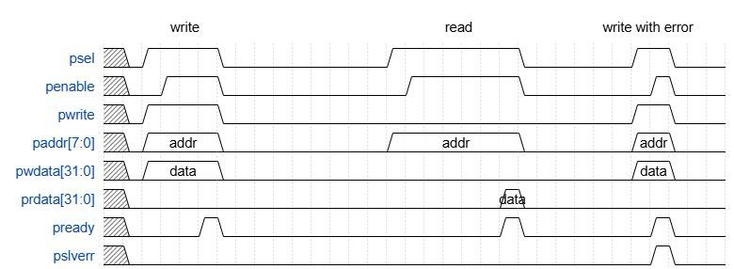
- DATA_WIDTH: The size of the APB data bus

Waveforms
Figure 5. Waveforms for the APB protocol
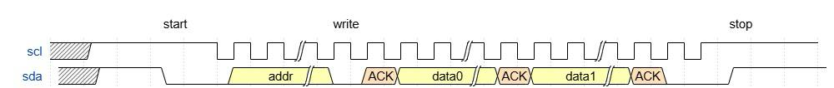

Figure 6. I2C waveforms for the I2C protocol (write)
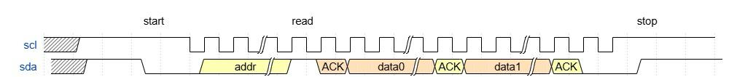

Figure 7. I2C waveforms for the I2C protocol (read)

Register table
Table 4. Table of the registers that can be accessed by the DUT
Register name | Access address | Register structure | Reset value | Description of the register fields
CONFIG | 0x00 | Field name Bit  FREQ 15  14  ADDR 13  12  11  10  9  8  7  ENDIAN 6  INFRARED_ON 5  BLUE_ON 4  GREEN_ON 3  RED_ON 2  CLEAR_ON 1  SD 0 | 0x01 | R/W configuration register
CLEAR_CH | 0x02 | Little Endian  15-8 7-0  LSB MSB  Big Endian  15-8 7-0  MSB LSB | 0x00 | Clear (transparent)
RED_CH | 0x04 |  | 0x00 | Red color
GREEN_CH | 0x06 |  | 0x00 | Green color
BLUE_CH | 0x08 |  | 0x00 | Blue color
INFRARED_CH | 0x0C |  | 0x00 | Infrared light
SEED | 0x10 | 15-8 7-0  MSB LSB | 0xACE1 | LFSR seed
STATUS | 0x12 | Field name Bit  RESERVED 15-3  NACK 2  BSY 1  STATUS 0 | 0x00 | Sensor status

- Configuration register
Field name | Bit | Description
FREQ | 15 | 00 = 100 kHz; 01 = 400 kHz ; 10 = 1 MHz ; 11 = 3.4 MHz
 | 14
ADDR_I2C | 13 | The address that must be accessed on I2C
 | 12
 | 11
 | 10
 | 9
 | 8
 | 7
ENDIAN | 6 | 0 = LITTLE ENDIAN; 1 = BIG ENDIAN
INFRARED_ON | 5 | Turn on Infrared channel; 1 = power on; 0 = shutdown (default)
BLUE_ON | 4 | Turn on Blue channel; 1 = power on; 0 = shutdown (default)
GREEN_ON | 3 | Turn on Green channel; 1 = power on; 0 = shutdown (default)
RED_ON | 2 | Turn on Red channel; 1 = power on; 0 = shutdown (default)
CLEAR_ON | 1 | Turn on Clear channel; 1 = power on; 0 = shutdown (default)
SD | 0 | Shutdown setting; 0 = power on; 1 = shutdown

- Status register
Field name | Bit | Description
Reserved | 15-3 | -
NACK | 2 | 0 = ACK; 1 = NACK (from I2C)
BSY | 1 | 0 = Free; 1 = Busy
STATUS | 0 | 0 = Off; 1 = On

Verification of the circuit digital design
Verification environment architecture
List of elements to be verified
Functional coverage elements
Verification scenarios and tests
Results obtained

Verification environment architecture
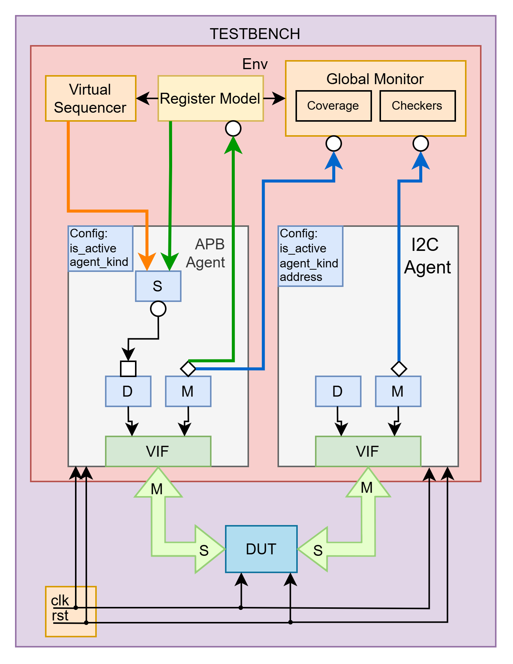
Figure 8. Example overview of the verification environment

Driver for the APB interface
The apb_driver class is an extension of the uvm_driver class, parameterized with the address and data widths (APB_AW, APB_DW). This class models a master-type driver for the APB interface.
In build_phase the virtual interface is initialized through uvm_config_db.
In run_phase, after waiting for the initial reset to pass, two processes are started that run in parallel inside a join_any fork.
One process calls the wait_reset() task, which waits to detect the assertion of the reset and initializes the signals for the APB interface.
The other process takes sequence items from the APB sequencer, calls the drive_trans() task, and then signals to the sequencer that the current transaction has finished and that the driver is ready to receive another.
The drive_trans() task, after waiting the number of clock cycles corresponding to the value of the delay field in the transaction, sets the address, asserts the psel signal and, depending on the operation type (write or read), drives the pwrite signal to 1 or 0. If it is a write operation, the data is also placed on pwdata. The task then waits one clock cycle and asserts the penable signal. It then waits for the pready signal to be asserted by the DUT, after which the control signals are deasserted.
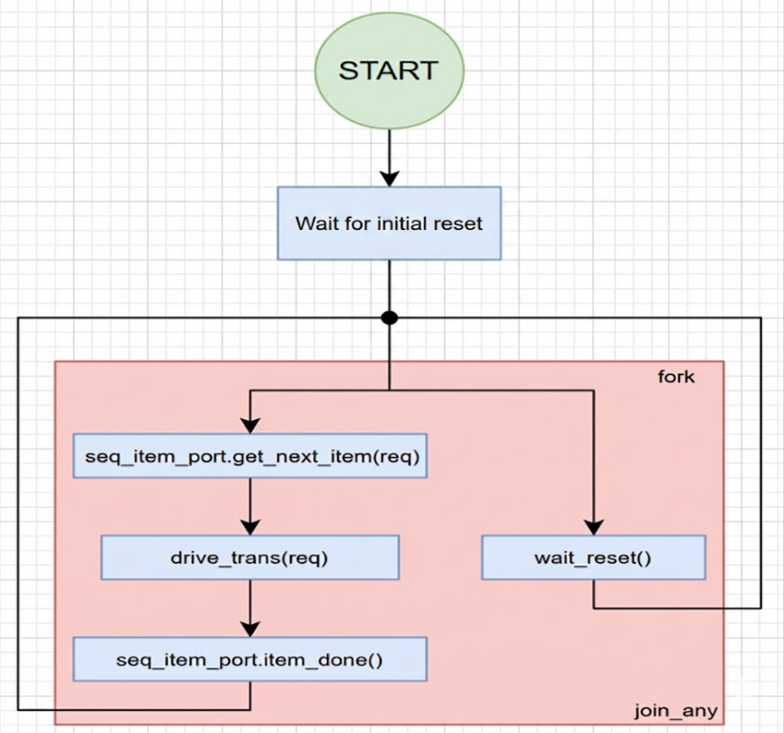
Figure 9. Logic flow diagram of the APB driver

Driver for the I2C interface
The I2C driver waits to detect the START condition, checks whether the received address equals the agent's address and whether the access is a write, and then sends the address response. If the address matches, after receiving each word it sends the data response until it detects the STOP condition.
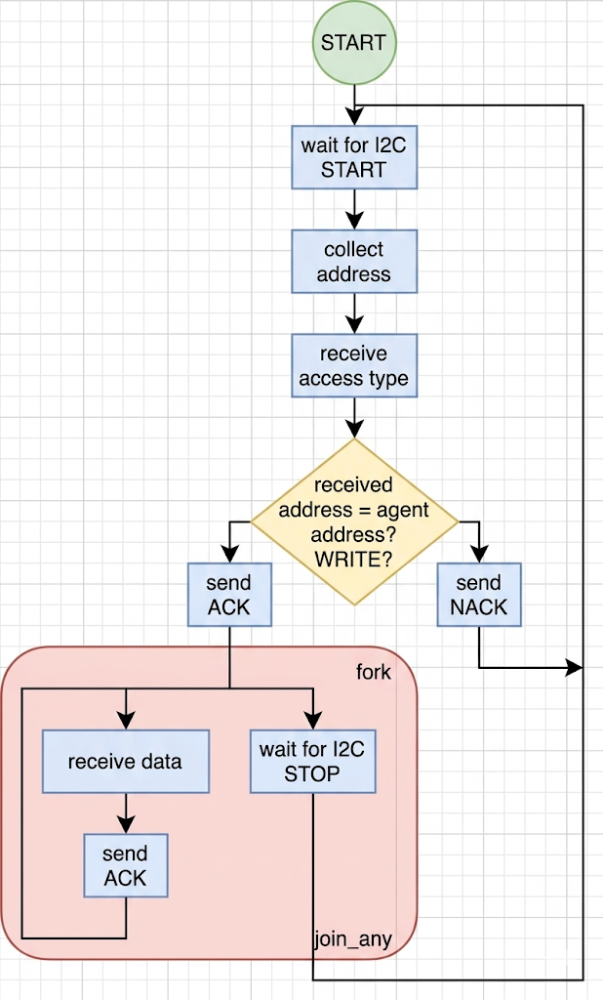
Figure 10. Logic flow diagram of the I2C driver

Scoreboard / reference model
The scoreboard handles the APB and I2C transactions, storing the data in the corresponding registers and verifying their integrity through assertions. It also collects coverage information to evaluate the degree of testing of the DUT registers. The scoreboard uses two functions, write_apb and write_i2c.
The write_apb function is used for processing APB transactions. APB transactions are used for configuring the registers and storing the read color data. Thus, this function uses assertions to verify whether the configuration data of the transactions matches the data in the registers.
The write_i2c function is used for processing I2C transactions. I2C transactions are used for transferring the data about the read colors. This function thus verifies whether the data transmitted over I2C is the same as the data in the respective color registers.

Monitor for the APB interface
The apb_monitor class is an extension of the uvm_monitor class, parameterized with the address and data widths (APB_AW, APB_DW). This class models a passive monitor for the APB bus, responsible for observing and collecting the transactions that take place on the APB interface, without influencing its behavior.
In build_phase the virtual interface is obtained from the UVM database, and if the interface is not set, execution is stopped with a fatal error.
In run_phase the monitor waits for the reset to be deasserted, then starts the parallel execution of three tasks using fork join_any.
The collect_transactions() task waits for the psel, penable and pready signals to be active simultaneously, the moment at which a transaction is considered valid. The address (paddr), the operation type (read/write depending on pwrite), the data (pwdata or prdata) and the error bit (pslverr) are extracted. The transaction is then forwarded through apb_port.
The delay_counter() task computes the delay between transactions. It monitors the psel signal and counts the clock cycles in which it is not active, in order to determine the delay between transactions. The delay value is then associated with the current transaction.
Another task started in parallel detects the assertion of the reset signal, and when it is active it stops the other parallel tasks.
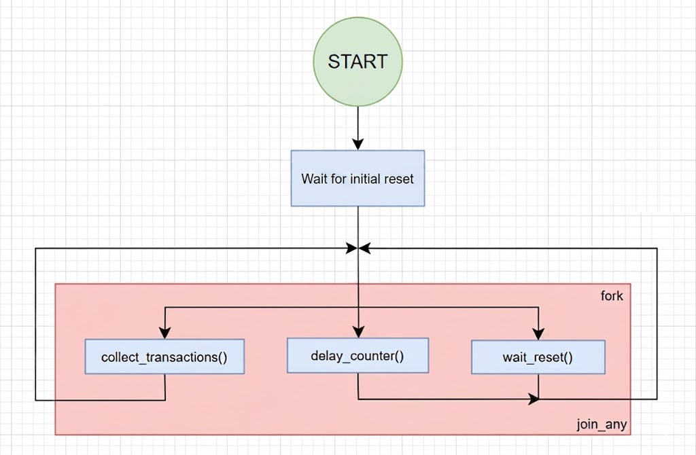
Figure 11. Logic flow diagram of the APB monitor

Monitor for the I2C interface
The I2C monitor watches the I2C interface and waits to detect the START condition. It collects the transaction until it detects the STOP condition and sends it through a port to the Scoreboard and the I2C coverage collector.
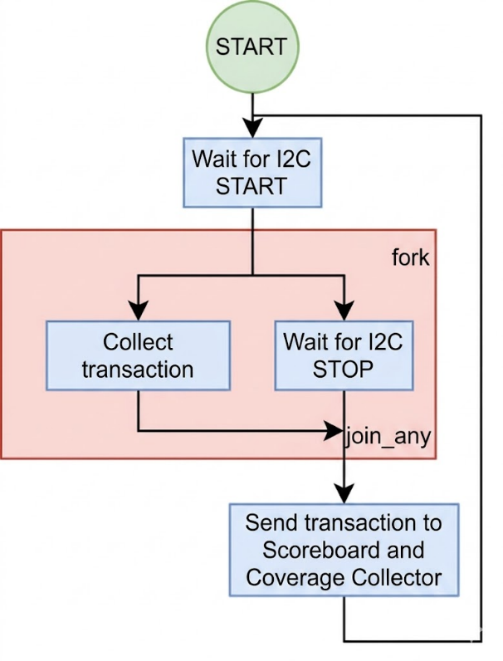
Figure 12. Logic flow diagram of the I2C monitor

Transaction for the APB interface
Table 5. The fields of the APB transaction
Field name | Data type | Size | Values | Description
addr | bit | `APB_AW-1 | [0:1F] | APB address
data | bit | `APB_DW-1 |  | Transmitted data
access | access_kind | 1 | {READ, WRITE} | Access type
trans_delay | int | 32 | [1:5] | Delay between transactions
slv_error | bit | 1 | [0:1] | Error signal from the DUT

`APB_AW and `APB_DW are two defines declared in the file apb_defines.sv and serve to increase the configurability of the APB UVC. If the user wishes to change the size of the data bus or the address bus, this can be done very easily by simply changing the value of those two defines, without needing to replace the value in all the UVC files.
The default value of the address bus is 5 bits, and that of the data bus is 32 bits.

Transaction for the I2C interface
Table 6. The fields of the I2C transaction
Field name | Data type | Size | Values | Description
addr | bit | 7 | [0:7F] | I2C address
access | access_kind | 1 | {READ, WRITE} | Access type
nr_words | int | 32 | 10 | Number of words
data | bit | 10x8b |  | Data vector
addr_resp | resp_kind | 1 | {ACK, NACK} | Address response
data_resp | resp_kind | 1 | {ACK, NACK} | Response of the last data word

Agent for the APB interface
The APB agent is an active agent, the APB having the role of Master in this project. It contains the driver, the monitor and the sequencer for APB.

Agent for the I2C interface
The I2C agent has the role of Slave, being reactive. It contains the I2C Driver, the I2C Monitor and the I2C coverage collector. It receives the I2C address from the verification environment and passes it to the Driver.

Coverage collector for the I2C interface
Coverpoint | Values | Description
addr_cov | [0:127] | Transactions are performed with all addresses
addr_resp_cov | ACK, NACK | Both types of address response are received
data_resp_cov | ACK, NACK | Both types of data response are received
data_cov | [0:0xFF] | All data bits toggle

Coverage collector for the scoreboard / reference model
Coverpoint | Values | Description
reg_config[15:14] | 00, 01, 10, 11 | Checks the operating-frequency values of the DUT
reg_config[13:7] | [0:127] | Checks the addresses used for performing I2C transfers
reg_config[6] | 0,1 | Checks the Little Endian / Big Endian setting
reg_config[5] | 0,1 | Checks the infrared channel state (on/off)
reg_config[4] | 0,1 | Checks the blue channel state (on/off)
reg_config[3] | 0,1 | Checks the green channel state (on/off)
reg_config[2] | 0,1 | Checks the red channel state (on/off)
reg_config[1] | 0,1 | Checks the clear channel state (on/off)
reg_config[0] | 0,1 | Checks the DUT state (on/off)
clear_ch | [0:127] | Checks the values received on the Clear channel
red_ch | [0:127] | Checks the values received on the Red channel
green_ch | [0:127] | Checks the values received on the Green channel
blue_ch | [0:127] | Checks the values received on the Blue channel
infrared_ch | [0:127] | Checks the values received on the Infrared channel
status[2] | ACK, NACK | Checks the reception of ACK/NACK
status[1] | 0, 1 | Checks the Available/Busy state
status[0] | 0,1 | Checks the register on/off state

The scoreboard coverage collector monitors the input combinations sent to the DUT in order to build a coverage report. Several coverage points (coverpoints) were defined:
- A coverage point for the configuration register, with all its fields
- A coverage point for each color channel, including clear and infrared
- A coverage point for the status register, with all its fields
- A coverage point for the seed register

List of elements to be verified
Table 5. The assertions on the APB interface
Checker | Description
x_z_state_check | The signals will never be x or z
stable_signal_check | The signals do not change before pready
penable_check | penable is not asserted without psel

Table 6. The assertions on the I2C interface
Checker | Description
x_z_state_check | The signals will never be x or z
sda_stable_check | SDA does not change while SCL is asserted
scl_full_cycle_check | SCL always completes a full cycle
scl_stable_check | SCL does not change outside of a transfer

Table 7. The checkers in the scoreboard
Checker | Description
write_apb | Checks the DUT configuration register through an APB transfer
write_i2c | Checks the correct execution of the data transfer over I2C

Functional coverage elements
Table 6. The functional coverage elements for the data on the output interface
Event: cover_trans_done_ev - emitted at the end of a burst transaction
Cover Point | Description
reg_config[15:14] | Checks the operating-frequency values of the DUT
reg_config[13:7] | Checks the addresses used for performing I2C transfers
reg_config[6] | Checks the Little Endian / Big Endian setting
reg_config[5] | Checks the infrared channel state (on/off)
reg_config[4] | Checks the blue channel state (on/off)
reg_config[3] | Checks the green channel state (on/off)
reg_config[2] | Checks the red channel state (on/off)
reg_config[1] | Checks the clear channel state (on/off)
reg_config[0] | Checks the DUT state (on/off)
clear_ch | Checks the values received on the Clear channel
red_ch | Checks the values received on the Red channel
green_ch | Checks the values received on the Green channel
blue_ch | Checks the values received on the Blue channel
infrared_ch | Checks the values received on the Infrared channel
status[2] | Checks the reception of ACK/NACK
status[1] | Checks the Available/Busy state
status[0] | Checks the register on/off state

Verification scenarios and tests
Table 7. The list of scenarios designed for verifying the DUT
Scenario title | Description of the proposed scenario
register reset | The register values will be read immediately after the reset signal was asserted, in order to verify their value
register access | All registers are written with random values, and then read back
LFSR | Writing the seed register with different values
transmission order | Changing the data transmission order (Little Endian, Big Endian)
clock frequency | Testing the correct data transmission with different frequency values
ON/ OFF | Disabling the color channels, verification on the I2C interface

Table 8. The list of tests implemented for verifying the DUT
Name of the file containing the test | Description of the test performed
test_registers.sv | In this test we verify the Read/Write functionalities of the registers.
test_functional.sv | In this test we verify whether the I2C protocol works correctly.

Results obtained
The three tests were run in the Xilinx Vivado simulator (XSim, UVM 1.2). All passed with 0 errors and 0 warnings.
Running test_base.sv (5 random APB transactions):
- APB transactions captured: 5 / 5
- APB functional coverage: 41.67% | I2C functional coverage: 0.00%
Running test_registers.sv (read defaults → random write → read-back):
- APB transactions captured: 24 / 24
- APB functional coverage: 72.22% | I2C functional coverage: 0.00%
Running test_functional.sv (configuration + continuous I2C transmission):
- APB transactions captured: 12 / 12
- I2C transactions verified: 1 / 1 (address 0x29, WRITE, 10 data bytes, ACK + valid STOP)
- APB functional coverage: 20.83% | I2C functional coverage: 46.88%
All protocol assertions on the APB and I2C interfaces (3 APB + 4 I2C checkers) passed without failures throughout every simulation. I2C coverage is 0% in test_base and test_registers because these tests do not activate the sensor; the I2C data path is exercised by test_functional.

